**Not null 제약**

1. **Create Table sample631(**

**A integer not null,**

**B integer);**

1. **Desc sample631;**
2. **Insert into sample631 values(1,1);**
3. **Insert into sample631 values(null,null);**
4. **Insert into sample631 values(1,null);**

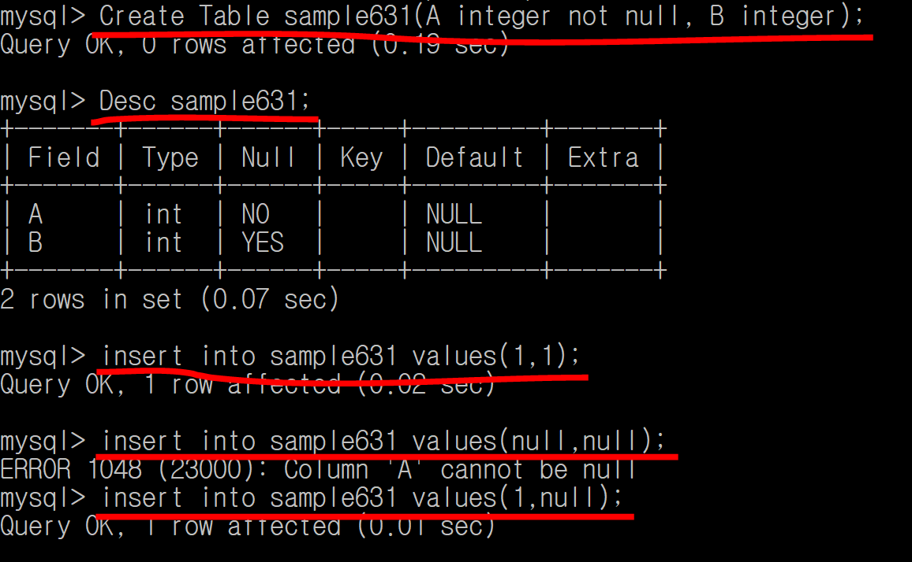

**Not null 제약 🡪 내용에 null값을 넣지 못함!**